**Solution for Question 3:**

**Created new branch "geometry-calculator"**

kiran@Radha-Krishna-01 MINGW64 /d/DevOps_Cert/git_assignment_HeroVired (main)

$ git checkout -b geometry-calculator

Switched to a new branch 'geometry-calculator'

**Created and add the new file calculate_area.py to tracker and committed:**

Kiran@Radha-Krishna-01 MINGW64 /d/DevOps_Cert/git_assignment_HeroVired (geometry-calculator)

$ nano calculate_area.py

Kiran@Radha-Krishna-01 MINGW64 /d/DevOps_Cert/git_assignment_HeroVired (geometry-calculator)

$ ls

CalculatorPlus.py README.md calculate_area.py

Kiran@Radha-Krishna-01 MINGW64 /d/DevOps_Cert/git_assignment_HeroVired (geometry-calculator)

$ git add calculate_area.py

warning: in the working copy of 'calculate_area.py', LF will be replaced by CRLF the next time Git touches it

Kiran@Radha-Krishna-01 MINGW64 /d/DevOps_Cert/git_assignment_HeroVired (geometry-calculator)

$ git commit -m "Initial commit of Calculate Area app geometry-calculator branch"

[geometry-calculator c6796f8] Initial commit of Calculate Area app geometry-calculator branch

1 file changed, 27 insertions(+)

create mode 100644 calculate_area.py

Kiran@Radha-Krishna-01 MINGW64 /d/DevOps_Cert/git_assignment_HeroVired (geometry-calculator)

$ git status

On branch geometry-calculator

nothing to commit, working tree clean

**Created a new branch - feature/circle-area**

Kiran@Radha-Krishna-01 MINGW64 /d/DevOps_Cert/git_assignment_HeroVired (geometry-calculator)

$ git checkout -b feature/circle-area

Switched to a new branch 'feature/circle-area'

**Updated code to have area of circle code with the feature branch and saved off the changes using git stash**

Kiran@Radha-Krishna-01 MINGW64 /d/DevOps_Cert/git_assignment_HeroVired (feature/circle-area)

$ nano calculate_area.py

Kiran@Radha-Krishna-01 MINGW64 /d/DevOps_Cert/git_assignment_HeroVired (feature/circle-area)

$ git add calculate_area.py

Kiran@Radha-Krishna-01 MINGW64 /d/DevOps_Cert/git_assignment_HeroVired (feature/circle-area)

$ git status

On branch feature/circle-area

Changes to be committed:

(use "git restore --staged <file>..." to unstage)

modified: calculate_area.py

Kiran@Radha-Krishna-01 MINGW64 /d/DevOps_Cert/git_assignment_HeroVired (feature/circle-area)

$ git stash

Saved working directory and index state WIP on feature/circle-area: 557cee2 Initial commit of the Calc plus app on Dev

**Verified that working directory is clean post stashing the change:**

Kiran@Radha-Krishna-01 MINGW64 /d/DevOps_Cert/git_assignment_HeroVired (feature/circle-area)

$ git status

On branch feature/circle-area

nothing to commit, working tree clean

**Switched to Feature Rectangle area:**

Kiran@Radha-Krishna-01 MINGW64 /d/DevOps_Cert/git_assignment_HeroVired (feature/circle-area)

$ git switch feature/rectangle-area

Switched to branch 'feature/rectangle-area'

**Updated the app to have area of rectangle code:**

Kiran@Radha-Krishna-01 MINGW64 /d/DevOps_Cert/git_assignment_HeroVired (feature/rectangle-area)

$ nano calculate_area.py

Kiran@Radha-Krishna-01 MINGW64 /d/DevOps_Cert/git_assignment_HeroVired (feature/rectangle-area)

$ git add calculate_area.py

Kiran@Radha-Krishna-01 MINGW64 /d/DevOps_Cert/git_assignment_HeroVired (feature/rectangle-area)

$ git status

On branch feature/rectangle-area

Changes to be committed:

(use "git restore --staged <file>..." to unstage)

modified: calculate_area.py

Kiran@Radha-Krishna-01 MINGW64 /d/DevOps_Cert/git_assignment_HeroVired (feature/rectangle-area)

$ git stash

Saved working directory and index state WIP on feature/rectangle-area: c6796f8 Initial commit of Calculate Area app geometry-calculator branch

**Validated that working tree is clean:**

Kiran@Radha-Krishna-01 MINGW64 /d/DevOps_Cert/git_assignment_HeroVired (feature/rectangle-area)

$ git status

On branch feature/rectangle-area

nothing to commit, working tree clean

**Switched to Feature Circle branch and retrieved the changes, added to tracker and committed:**

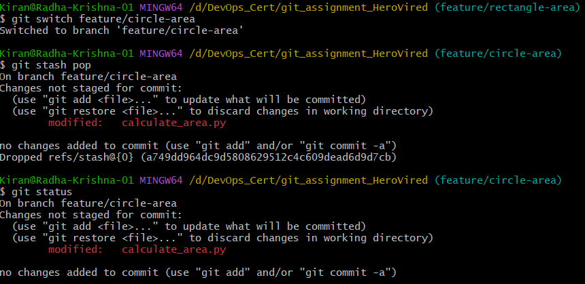

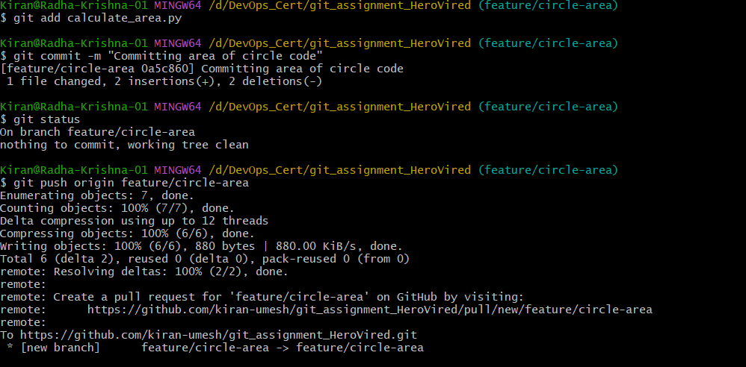

**Switched to Feature Reactnagle branch and retrieved the changes, added to tracker and committed:**

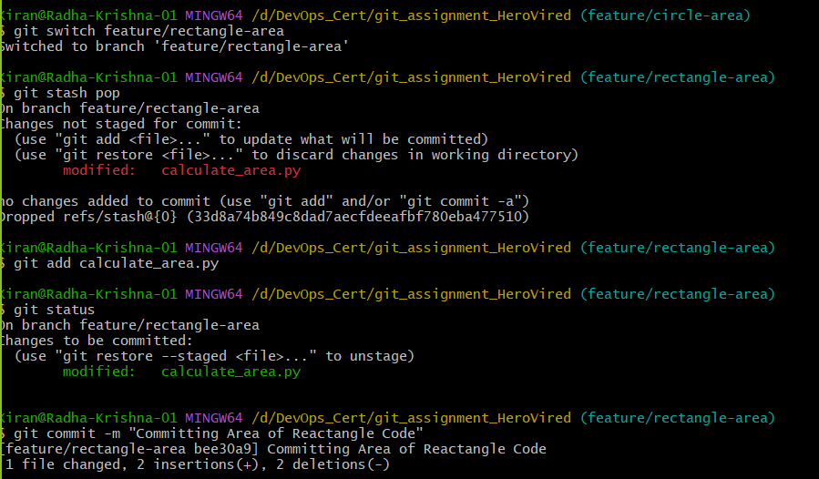

Merge of Feature/Circle code to Dev has been approved by collaborator:

Merge of Feature/Rectangle code to Dev has been approved by collaborator:

Raised and merged the final merge of Dev branch onto Main branch:

